Name: _____________________ Class:__________ Date:__________
Instructions: Write answers in the right-hand column. Score: ___________ / 49 marks
Section A— Multiple choice (10 marks)

 | Core body temperature for a living human is:  A 37°C  B 100°C  C 25°C  D 35°C | A | 1
 | The shape of the drops of blood can be used to determine what happened at a crime scene. What do circular drops of blood indicate?  A The blood dropped vertically from a short distance.  B The blood dropped a long way vertically.  C The person was running as they were bleeding.  D The person was slowly moving away from the scene as they were bleeding. | a | 1
 | Which of the following statements about porous surfaces is INCORRECT?  A Porous surfaces absorb sweat, oils and grease.  B Glass is an example of a porous surface.  C Fingerprints are harder to find on porous surfaces than non-porous surfaces.  D Fingerprints on porous surfaces can be revealed by brushing them with a chemical that reacts with the fingerprint. | b | 1
 | What is the reason a body turns green within two days of death?  A Bacteria are starting to decompose the body.  B Fungi are starting to decompose the body.  C People often have a green complexion when not feeling well.  D Moss is starting to grow on the body. | a | 1
 | Some techniques of identification prove that someone is definitely the criminal that police are looking for. Other techniques give clues but aren’t definite. Which of the following CANNOT be used to definitely identify a criminal?  A iris patterns  B blood type  C fingerprints  D DNA | b | 1
 | DNA fragments are separated using:  A gel electrophoresis  B chromatography  C blood typing  D dusting for fingerprints | a | 1
 | A mobile phone can be used to locate someone in the first few days after they have gone missing. After this time it usually will not be of help. The most likely reason for this is that:  A the person has moved out of their local area  B the person remembered to turn the phone off  C the battery of the phone went dead  D the phone was thrown away | c | 1
 | What is a Smartgate?  A a gate that opens when it detects that you are there  B a self-service kiosk that reads ePassports at airports  C a self-service kiosk that takes photos of you  D a gate that is very intelligent | b | 1
 | Microprinting:  A is slightly raised  B is incredibly small  C glows when placed under UV light  D part of a hologram | b | 1
 | The process used to separate coloured dyes is called:  A gel electrophoresis  B chromatography  C chromaphoresis  D intaglio | B | 1

Section B— Short answer (29 marks)

 | Define the following terms:  a pathology  b ballistics  c corpse | a the study of disease and cause of death  b the study of guns and ammunition  c dead body | 3
 | State what the following acronyms mean:  a CSU  b CCTV | a CSU = Crime Scene Unit  b CCTV = Closed Circuit TV. | 2
 | List three examples each of:  a physical evidence  b trace evidence | a Physical evidence: bodies, bullets, weapons, blood samples, tool marks, broken furniture, insects etc.  b Trace evidence: DNA, blood type, seeds, fibres, hairs | 6
 | A criminal may clean a crime scene of all physical evidence but will not be able to clean it of all trace evidence. Explain why. | Physical evidence is evidence that can be easily seen. Because it can be seen, the criminal can clean it up or remove it. Trace evidence cannot be seen. Hence, despite attempts by the criminal to clean up, some trace evidence will always be left behind. | 2
 | List three types of identification commonly carried by people. | Driver’s licence, student card, credit card, Medicare card | 3
 | List two ways in which insects can be used to determine the place and time of death. | Each area has its own types of insects. Therefore, the type of insect can indicate if the body has been shifted from another place.  Insects pass through definite stages in their lifecycles. The stage found on the body gives an estimate of how long the person has been dead. | 2
 | Classify the following fingerprints as loop, whorl or arch.  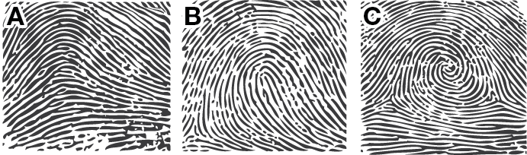 | A arch  B loop  C whorl | 3
 | Shoes can leave positive and negative impressions at a crime scene.  a Contrast positive and negative impressions.  b Someone wearing a pair of boots walked through some water and then onto dry concrete. Identify whether their boots would leave positive or negative impressions on the concrete.  c Someone wearing a pair of shoes ran across wet sand. Identify whether their shoes would leave positive or negative impressions. | a Positive impressions give the pattern of the sole itself while negative impressions give the pattern of the recesses in the sole.  b positive impressions  c negative impressions | 3
 | List two advantages of using polymer film (plastic) for banknotes instead of paper. | Polymer film is harder wearing than paper, giving the notes a much longer life before needing to be replaced.  Polymer film makes money almost impossible to counterfeit (copy). | 2
 | a State what identity fraud is.  b List two reasons why criminals might want to commit identity fraud. | a Identity fraud is when you pretend to be someone else.  b By taking on the identity of someone else, criminals can often access bank accounts, credit cards, cross international borders when they themselves cannot, enter high-security institutions, access sensitive files. | 3

Section C— Thinking scientifically (10 marks)

 | The core body temperature drops about 0.8°C every hour after death. How long would it normally take for the core body temperature to drop from 37°C to room temperature (25°C)?  A 15 hours  B 1 day  C 1.5 hours  D 12 hours | a | 1
 | Which of the following sketch graphs best represents what happens to the core body temperature after death?  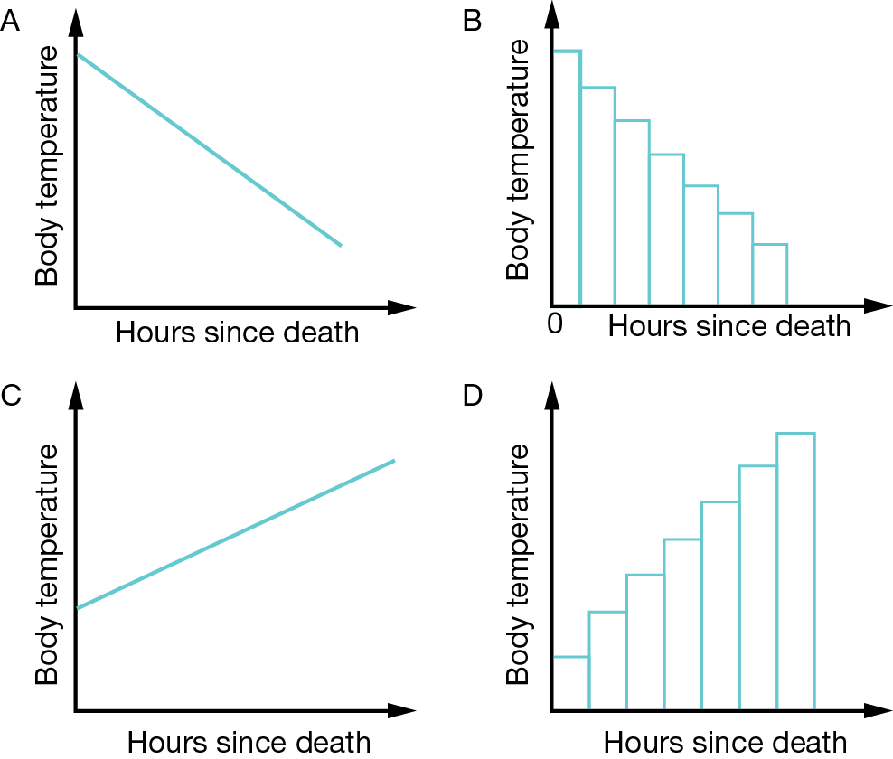 | a | 1
 | The day is a hot one (37°C) and a body has just been found. The temperature of the body is 37°C and its skin colour is pale green. State how long the person has probably been dead for.  A The person has just died.  B The person died two days ago.  C The person died within the last day.  D The person died a month ago. | b | 1
 | In which direction was the person moving to produce the blood splatter pattern shown below?  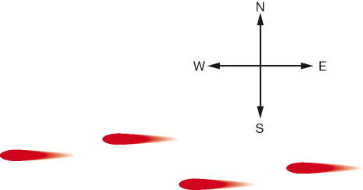  A north  B south  C east  D west | C | 1
 | Chromatography was used to determine which pen wrote a ransom letter. Determine which pen was used.  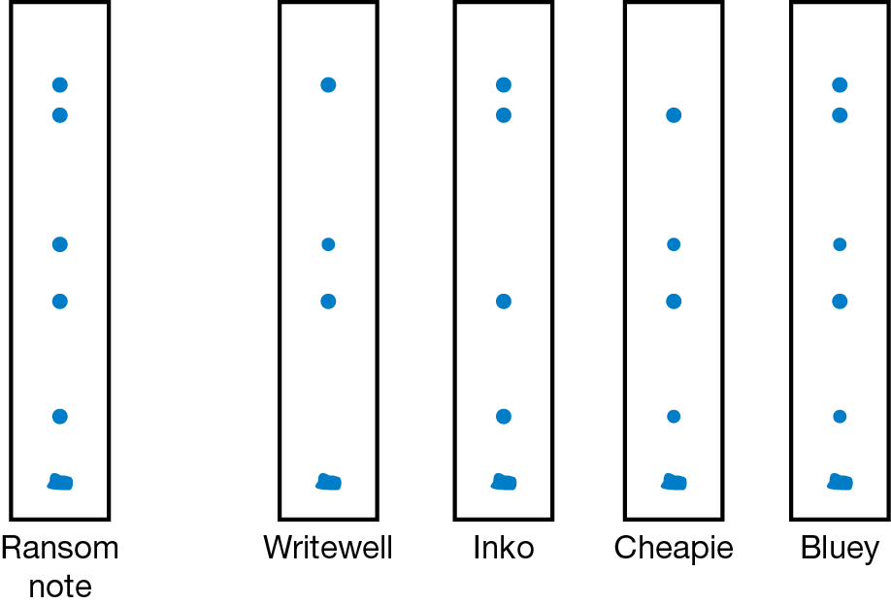  A Writewell  B Inko  C Cheapie  D Bluey | d | 1
 | The following autoradiogram was produced from the DNA found in a sample at a crime scene. DNA samples from four suspects were taken. From which suspect did the DNA found at the crime scene most likely come from?  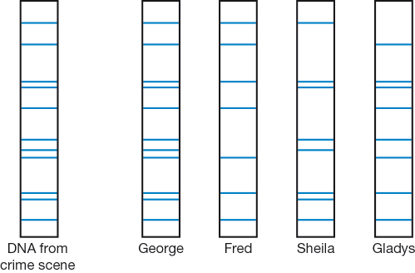  A George  B Fred  C Sheila  D Gladys | a | 1
 | The blood group of a person is determined by mixing it with antibodies called anti-A and anti-B. Depending on the blood group, nothing will happen or the sample will coagulate (clot). The possible results are shown in the table below.  An attacker was bleeding as she fled a crime scene. Blood from the crime scene was found to be of blood group AB. Blood samples were taken from the four most-likely four suspects. The results are shown below. Which of the four suspects is most likely to have committed the crime?  A Noelene  B Raelene  C Irene  D Kaylene | c | 1
  Blood group | Mixed with anti-A antibody | Mixed with anti-B antibody
  A | Coagulates | Nothing happens
  B | Nothing happens | Coagulates
  AB | Coagulates | Coagulates
  O | Nothing happens | Nothing happens
  Suspect | Noelene | Raelene | Irene | Kaylene
  Anti-A | Coagulates | Nothing | Coagulates | Coagulates
  Anti-B | Nothing | Coagulates | Coagulates | Nothing
 | The table below shows that some blood groups are more common in some racial groupings than others.  Using this information and the information from the previous question, what can be said about the most likely suspect?  A The suspect is most likely to be Asian.  B The suspect is most likely to be African.  C The suspect is most likely to be Caucasian.  D No particular racial grouping is more likely than any other. | d | 1
  Blood group | Proportion of Australians with that blood group | Most likely racial grouping
  A | 39% (A+ = 32%, A– = 7%) | Caucasian (European, North African, Middle Eastern)
  B | 11% (B+ = 9%, B– = 2%) | Asian, African
  AB | 4% (AB+ = 3%, AB– = 1%) | All racial groups
  O | 46% (O+ = 38%, O– = 8%) | All racial groups
 | The main bone of the leg (the femur) can give some indication of the height of a long-dead victim. The predicted height can be calculated using the formula:  For males, predicted height (in cm) = femur length × 2.238 + 69.089  For females, predicted height (in cm) = femur length × 2.317 + 61.412  The skeleton of a male is found in the bush. His femur was measured as 50 cm long. When alive, his height would have been be closest to:  A 1.8 m  B 3570 cm  C 267 cm  D 177 cm | A | 1
 | Imagine the 50 cm long femur had been from a woman instead of a man. Compare her height when alive with that of a man with an identically sized femur.  A She would be shorter.  B She would be taller.  C She would have the same height as the man.  D There is insufficient information to decide. | a | 1

